MANCHITRA: AI for Community Visuals
Community Project Report
Submitted by
SARTHAK RUNTHALA  (23331A4758) | R.YASWANTHI KUMARI  (23331A4755)
P.S.SAI BALAJI  (23331A4746) | K.SHIVA SANKAR  (23331A4723)
In partial fulfillment for the award of the degree
of
BACHELOR OF TECHNOLOGY
IN
COMPUTER SCIENCE & ENGINEERING
(Artificial Intelligence & Machine Learning)
Under the esteemed Guidance of

G. Gayathri
Assistant Professor



DEPARTMENT OF DATA ENGINEERING

MAHARAJ VIJAYARAM GAJAPATHI RAJ COLLEGE OF ENGINEERING (Autonomous)

(Approved by AICTE, New Delhi, and permanently affiliated to JNTUGV, Vizianagaram), Listed u/s 2(f) & 12(B) of UGC Act 1956.

Vijayaram Nagar Campus, Chintalavalasa, Vizianagaram-535005, Andhra Pradesh

October, 2025

CERTIFICATE



This is to certify that the project entitled “MANCHITRA: AI for community Visuals” is the bonafide work carried out by Sarthak Ruthala(23331A4758), R.Yaswanthi Kumari(23331A4755),P.S.Sai Balaji(23331A4746), K.Shiva Sankar(23331A4723) of B.Tech V Sem CSE-ICB, M.V.G.R. College of Engineering (Autonomous), Vizianagaram, during the year 2025-2026, in partial fulfilment of the requirements for the award of the Degree of Bachelor of Technology and that the project has not formed the basis for the award previously of any degree or any other similar title.

Signature of Project Guide Signature of Head of the Department
G.Gayathri Dr.V.Jyothi
Assistant Professor Associate Professor
Dept. of Data Engineering. Dept. of Data Engineering.

DECLARATION

We hereby declare that the work done on the dissertation entitled “MANCHITRA: AI for Community Visuals” has been carried out by us and submitted in partial fulfilment for the award of credits in Bachelor of Technology in Computer Science and Engineering (Internet Of Things Cyber Security With Blockchain Technology) of M.V.G.R College of Engineering (Autonomous) and affiliated to JNTUGV, Vizianagaram. The various contents incorporated in the dissertation have not been submitted for the award of any degree of any other institution or university.

Sarthak Runthala
(23331A4758)

R. Yaswanthi Kumari
(23331A4755)

P.S.Sai Balaji
(23331A4746)

K. Shiva Sankar
(23331A4723)

ACKNOWLEDGEMENT

We express our sincere gratitude to (G.Gayathri) for his/her invaluable guidance and support as our mentor throughout the project. Her unwavering commitment to excellence and constructive feedback motivated us to achieve our project goals. We are greatly indebted to her for her exceptional guidance.
Additionally, we extend our thanks to Prof. P.S. Sitharama Raju (Director), Dr. Y.M.C. Shekar (Principal), and Dr. Jyothi (Head of the Department) for their unwavering support and assistance, which were instrumental in the successful completion of the project. We are thankful for and fortunate enough to get constant encouragement and guidance from our Project Coordinator Mrs. N. Sushma Rani.
We also acknowledge the dedicated assistance provided by all the staff members in the Department of Data Engineering. Finally, we appreciate the contributions of all those who directly or indirectly contributed to the successful execution of this endeavour.

Sarthak Runthala(23331A4758)
R. Yaswanthi Kumari(23331A4755)
P.S.Sai Balaji (23331A4746)
K.Shiva Sankar (23331A4723)

ABSTRACT

MANCHITRA: AI for Community Visuals is an AI-driven project that transforms community data into interactive visual maps and insights. It helps identify local challenges, track development, and support data-based decision-making. The project promotes transparency and community engagement through intelligent visualization tools.

The platform also supports community development by allowing visual representation of local issues, events, and projects. Through intelligent visualization tools, MANCHITRA enhances data-driven decision-making, promotes transparency, and encourages community engagement. It bridges the gap between information and understanding — turning ideas into impactful visuals.

TABLE OF CONTENTS
Contents | Page No.
List of Abbreviations
List of Figures
List of Tables
1. Introduction
1.1 Problem Statement
1.2 Project Objective
1.3 Scope of the Project
2. Literature Survey
3. Data Gathering / Data Used
4. Methodology / System Design
5. Implementation / Modules
6. Results / Outputs
7. Impact Assessment
8. Challenges Faced
9. Conclusion
10. Future Work
References
Appendix A: Packages, Tools Used & Working Process
• Packages & Tools Used
• Working Process
Appendix B: Source Code
Paper Publications (if any)

List of Abbreviations

Abbreviation Full Form

AI Artificial Intelligence
API Application Programming Interface
UI User Interface
UX User Experience
PNG Portable Network Graphics
DB Database
JSON JavaScript Object Notation
CSS Cascading Style .
HTML Hyper Text Markup Language
JS JavaScript
SDLC Software Development Life Cycle
CRUD Create, Read, Update, Delete
UI/UX User Interface / User Experience ML Machine Learning
CDN Content Delivery Network
IDE Integrated Development Environment
JSON API JavaScript Object Notation API
SPA Single Page Application
GUI Graphical User Interface
DBMS Database Management System
GIF GIF Graphics Interchange Format

LIST OF FIGURES:

Figure No. | Title | Page No.
6.1 | HOMEPAGE | 16
6.2 | GENERATED IMAGE OUTPUT | 16
6.3 | DASHBOARD | 17

- Introduction

- MANCHITRA: AI for Community Visuals is a community-driven project that uses Artificial Intelligence to create smart images. It helps people easily find essential places like hospitals, schools, and offices. By combining AI and geospatial data, the project aims to make community information more visual, accessible, and useful for everyone.​

  - Problem Statement

Many communities lack access to affordable, intuitive tools for creating custom visual content. Traditional design software is expensive and requires specialized skills, hindering effective communication for local outreach and awareness campaigns.​
​
Costly Software​
Traditional design tools are often prohibitively expensive.​
​
Skill Gap​
Specialized skills are needed ,creating a barrier for non-designers.​
​
Limited Outreach​
Ineffective communication for local education andawareness campaigns.​

​
  - Problem Objectives

Develop MANCHITRA ​
​
- A web-based, AI-powered image generator ​for community use.​
​
Enable Easy Creation​

- Users can create visually appealing, locally relevant content with minimal effort.​

Support Local Culture​
​
- Integrate local languages, symbols, and​cultural styles.​
​
Empower Users​

- Students, educators, and community workers ​can design posters and educational materials.

  - Scope of the Project

- The MANCHITRA project aims to develop an AI-powered platform that visualizes community data through interactive maps and graphics. It helps citizens, researchers, and local authorities understand community trends, resources, and development activities.​

In Scope:​
- AI-based analysis of community datasets (demographics, infrastructure, events).​
- Interactive visualizations (maps, charts, heatmaps) via a user-friendly interface.​
- Tools for awareness, planning, and collaboration within communities.​

Out of Scope:​
- Real-time tracking or surveillance.​
- Handling sensitive personal data.​
- Large-scale GIS or commercial deployment.​

Deliverables:​
- Functional prototype of the visualization tool.​
- Interactive dashboards showcasing AI-generated community insights.​
- Documentation covering system design, datasets, and usage guidelines.​

- Literature Survey

1.Existing Tools

Several AI-based image generation platforms currently exist, including DALL·E by OpenAI, Imagen by Google, and Bing Image Creator powered by Microsoft’s DALL·E integration.

These systems use advanced diffusion models and neural networks to create high-quality images from textual prompts. They demonstrate the immense potential of generative AI in creative design and digital visualization.

However, while these platforms excel in producing visually impressive results, they share certain limitations when it comes to localized or community-driven applications:

Lack of Cultural Context:
Tools like DALL·E and Imagen are trained primarily on global datasets, which often lack regional, cultural, or linguistic nuances. As a result, they struggle to generate visuals that represent local communities, traditional attire, environments, or educational contexts accurately.

Limited Accessibility:
Many of these tools require paid subscriptions, API credits, or high-end hardware for access, limiting their adoption among schools and community organizations with minimal technical infrastructure.

2. Education-Specific Tools

With the growth of AI in education, some platforms have begun to address classroom visualization needs.

For instance, Monsha.ai is an AI-based educational illustration tool that allows teachers to create diagrams, infographics, and classroom visuals. It helps educators quickly generate creative teaching aids using simple prompts.

However, despite being innovative, such education-focused solutions still face challenges:

Limited Accessibility:
Many tools like Monsha.ai or similar EdTech AI platforms follow a freemium model, where only a small portion of features are free, while advanced tools or high-resolution downloads require paid upgrades.

Restricted Flexibility:
These tools often have predefined templates or illustration styles, limiting creative freedom for users who want diverse or realistic image outputs.

Dependency on Internet & Central Servers:
Since they are fully cloud-based, their performance depends on continuous network connectivity — a barrier for schools or communities in semi-urban and rural areas.

3. The Gap

From the review of existing solutions, it is evident that a significant gap exists between high-end AI visualization systems and the needs of local educational or community users.

Generic Outputs:
Current AI tools are built on large, globally trained models that generate generic visuals. They lack the contextual sensitivity required for representing regional cultures, languages, and educational themes.

Accessibility & Complexity:
High costs, account requirements, and technical complexity make existing AI tools inaccessible for grassroots educators, NGOs, and local institutions.

Educational Context Missing:
Existing AI systems are rarely optimized for curriculum-based or thematic learning. They focus on aesthetic generation rather than conceptual or instructional visualization.

- Data Gathering / Data Used

1. Primary Data

User Interaction Studies:
Informal discussions and feedback were taken from students, teachers, and local community members to understand their visualization needs — such as generating educational diagrams, posters, and awareness visuals.
Observation & Requirement Analysis:
The interface requirements (ease of use, prompt customization, filters, etc.) were determined by observing how users interact with AI image generation tools and noting difficulties faced by non-technical users.
Testing Data:
Multiple text prompts were tested to verify accuracy, creativity, and cultural relevance of the images produced by the Pollinations AI API.

2. Secondary Data

AI Model Documentation:
Technical references and documentation from the Pollinations AI API and other image generation systems were studied to understand model parameters, input formats, and response structures.
Research Papers & Online Resources:
Literature on Generative AI, Diffusion Models, and AI in Education was reviewed to analyze trends and methods in AI-driven visualization.
Educational Material:
Textbook diagrams, infographics, and classroom visuals were used as benchmarks to design realistic and meaningful outputs for learning purposes.

3. Data Handling

The Pollinations API dynamically generates image data based on user prompts; therefore, no static dataset is stored.
Generated images and related metadata (prompt, style, timestamp, filters, orientation) are securely stored in Firebase Firestore and Storage for each authenticated user.
No personal user data beyond basic authentication information (email, name, profile image) is collected, ensuring privacy and ethical use.

- Methodology / System Design

Start​
- The system initializes and waits for user input​
Input Text or Description​
- User provides input in the form of text ​
Data Processing & Analysis​
- The text input is sent to the AI language and data module.​
Convert Text to Structured Visual Data​
- Converts the interpreted data into a structured format suitable for visualization.​
Generate Visualization​
- The visualization module creates the images using processed data.​
Render Final Image Output​
- The final stage where the system renders and displays the visual result.​
End​
- The process completes successfully.​

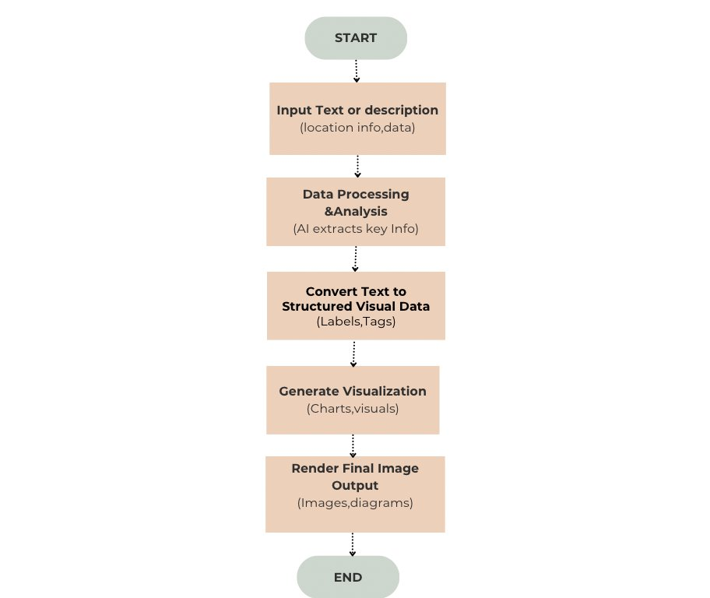

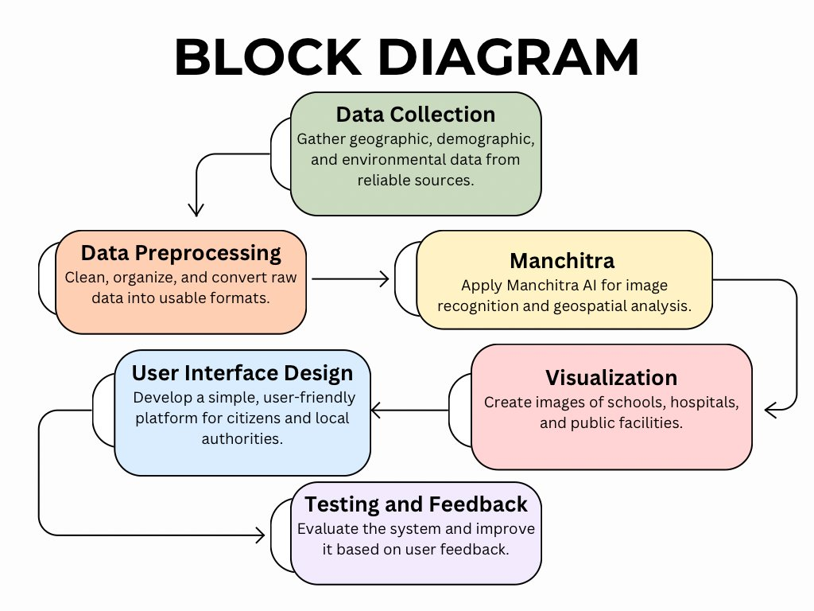

The Frontend Layer is developed using React.js and TailwindCSS. It provides an interactive and user-friendly interface where users can enter prompts, choose between realistic or cartoonish styles, apply filters, and view the generated images. This layer is responsible for collecting input data from users and displaying the output received from the AI model.

The Backend or API Layer acts as the communication bridge between the user interface and the AI model. It sends the user’s prompt and selected options to the Pollinations AI API, which processes the input and returns generated image URLs. This layer ensures smooth and secure data exchange between the frontend and the AI service.

The Database & Cloud Layer is implemented using Firebase services. It handles user authentication (email and Google login), stores generated images, and maintains metadata such as prompt history, applied filters, and timestamps. The Firestore database manages structured user data, while Firebase Storage keeps the generated visuals securely stored.
- Implementation / Modules

1. Data Collection Module

This module is responsible for gathering essential community-related data and textual inputs. Information such as local landmarks, public facilities, routes, schools, and development areas was collected through surveys, observations, and online references.
In addition to real-world data, textual prompts from users are also collected for generating educational or community visuals. The data serves as the foundation for generating contextually relevant images using the AI model.

2. Data Processing Module

The collected data is cleaned, categorized, and converted into a digital format suitable for analysis and AI visualization. Duplicate entries and irrelevant information are removed to ensure accuracy.
Text-based prompts are refined and structured to match the input syntax requirements of the Pollinations AI API. This preprocessing ensures that the AI receives precise and meaningful input to generate effective visual outputs.

3. Map Creation / Image Generation Module

This is the core module of the system. It integrates the Pollinations AI API to transform the processed data or text prompts into realistic or cartoonish images.
Depending on user preferences, the system can generate up to three images per prompt.

4. Testing and Validation Module

In this stage, the generated visuals are tested for accuracy, quality, and clarity.
The testing process includes:
Verifying that visuals correctly reflect the entered prompt.
Checking for distortions, missing elements, or low-resolution outputs.
Ensuring that downloaded images maintain the correct orientation (landscape or portrait).Feedback from users and community participants is used to refine the generation logic and UI components.

- Results / Outputs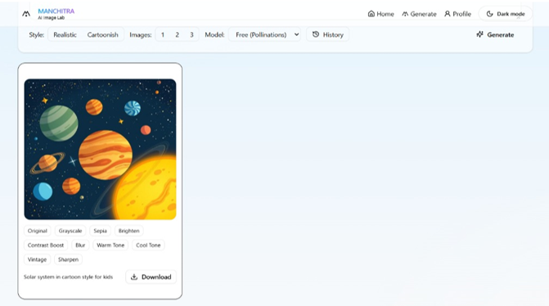

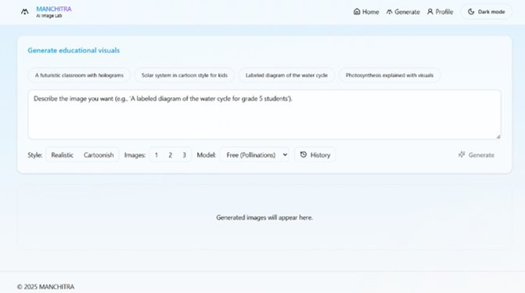

The MANCHITRA system successfully generates AI-based visuals from user prompts with high clarity and accuracy. Users can input text, choose between realistic or cartoonish styles, and generate up to three images at a time. The generated visuals are displayed in a clean, responsive layout with real-time filter options for enhancement. Images can be downloaded instantly in PNG format (landscape or portrait) or saved to the user’s dashboard for later use. The output results show that the system effectively transforms textual descriptions into meaningful visuals, suitable for educational, community, and awareness purposes, while maintaining speed, accuracy, and user interactivity.

- Impact Assessment

Simplifies Creation​
- ​Easy generation of posters, educational visuals, and cultural illustrations.​

Accessible Design​

- Digital design becomes available to underserved or non-technical users.​

Promotes Identity​

- Fosters regional identity and visual storytelling.​

Facilitates Communication​

- Faster, cost-effective communication for NGOs, educators, and local bodies.​

Inspires Creativity​

- Encourages self-expression among students and community members.

- Challenges Faced

- Collecting correct and updated community data.​
- Combining different types of data into one system.​
- Fixing errors and missing information in the data.​
- Keeping user data safe and private.​
- Creating a simple and easy-to-use design for everyone.​
- Handling limited tools and resources for data processing.​
- Making sure AI supports people’s decisions, not replaces them.​

- Conclusion

- The MANCHITRA: AI for Community Visuals project demonstrate show AI and data visualization can empower communities through insight and collaboration. By converting raw data into meaningful visual representations, it enables better understanding, planning, and decision-making. Ultimately, MANCHITRA fosters transparency, inclusivity, and sustainable community development through the power of intelligent technology.​

- Future Work

- Enhance AI models for better data analysis and predictions.​
- Add real-time data integration for live community updates.​
- Develop a mobile-friendly version of the platform.​
- Include multi-language and feedback features for inclusivity.​
- Expand data sources to cover health, education, and environment.​
- Deploy on cloud for scalability and wider accessibility.​
​

Appendix A: Packages, Tools Used & Working Process

● Frontend: React.js, TailwindCSS, Framer Motion — for building an interactive and responsive user interface
● Backend / API: Pollinations AI API — for AI-based image generation from user prompts
● Database & Auth: Firebase (Authentication, Firestore, Storage) — for secure login, data handling, and image storage
● Deployment: Vercel — for hosting and serverless deployment
● Development Tools: Node.js & npm (package management), VS Code (IDE), Git & GitHub (version control)

Working Process

The working process of MANCHITRA involves gathering user requirements and designing a modular system architecture that integrates AI with a user-friendly interface. The frontend was developed using React.js and TailwindCSS to ensure responsiveness and interactivity. The Pollinations AI API was integrated to generate images from user-provided prompts, while Firebase handled authentication, database management, and image storage. The system was then tested for functionality, accuracy, and performance, ensuring smooth user experience across all modules. Finally, the project was deployed on Vercel for online accessibility and reviewed by users for validation and improvements.

Appendix B: Source Code

● Code repository is hosted at: https://github.com/mortalengine7/MANCHITRA

● Major files include:
• /src/App.jsx - main frontend logic and component rendering
• /src/components/PromptPanel.jsx - handles user input, style selection, and generate button
• /src/components/ImageGrid.jsx - displays generated images with filters and download options
• /src/lib/firebase.js - Firebase configuration and initialization (Auth, Firestore, Storage)
• /src/api/generateImage.js - Pollinations AI API integration for image generation
• /src/components/AuthForm.jsx - user sign-up, login, and Google authentication UI
• /src/components/FiltersPanel.jsx - provides real-time filter controls for images

References

- Google Cloud. AI and Data Visualization Tools. Retrieved from https://cloud.google.com/​
- IBM Research. Artificial Intelligence for Social Good. Retrieved from https://research.ibm.com/​
- World Bank. Community Data for Development and Planning. Retrieved from https://www.worldbank.org/​
- Esri. GIS and Mapping for Community Engagement. Retrieved from https://www.esri.com/​
- UNDP. Leveraging Technology for Sustainable Community Development. Retrieved from https://www.undp.org/​
- Kaggle. Community Data Visualization Projects. Retrieved from https://www.kaggle.com/

Font Guidelines for the document
Content
Heading- Times New Roman 16 Bold ALL CAPITAL LETTERS
Sub-headings - Times New Roman 14 Bold
Body Text - Times New Roman 12 Line Spacing 1
Tables
List of Tables
Table No. | Title | Page No.
Table x.x
- Font: Times New Roman
- Size: 12 pt
- Table Heading: Bold (centered)
- Column Text: Regular (left-aligned)
- Line Spacing: 1.15

Figures
List of Figures
Figure No. | Title | Page No.
Figure x.x

Font Guidelines:
- Font: Times New Roman
- Size: 12 pt
- Figure Heading: Bold
- Figure Numbers: Sequential (chapter-based, e.g., Figure 2.1 for Chapter 2)

Reference Style
[1] Author(s), “Title,” Journal/Conference, vol., no., pp., year. DOI/URL

